Title

by

Midshipman 1/C (First Last), Midshipman 1/C (First Last), and Midshipman 1/C (First Last)

Contact Information: consider including civilian e-mail addresses in case a group from next year’s class would like to continue your project and would like to contact you with questions.



A Capstone Project Report Submitted to the Faculty of

The Weapons, Robotics and Control Engineering Department

United States Naval Academy, Annapolis, Maryland

Faculty Advisor: (Title First Last)

Department Chair: Prof Brad Bishop

Outside Sponsor: (If applicable, otherwise remove)

Date

Contents

PREFACE: Using the Template 4

Introduction 5

Motivation 5

Problem Statement 5

Related Work 5

Design Process 5

Objectives and PCC 5

Constraints 5

Functions and Morphological Chart 5

Ethical Considerations 5

Engineering Analysis or Simulations 5

Component Selection 6

Design Evolution 6

Final Design 6

Overview 6

Mechanical Subsystem 6

Electrical Subsystem 6

Software Subsystem 7

Feedback Control 8

Results and Analysis 9

Demonstration Plan 9

Performance Measures 9

Project Management 9

Work Breakdown Structure 9

Life Long Learning 9

Cost Analysis and Parts List 9

Timeline 9

Discussion and Conclusion 10

Acknowledgement 10

References 10

Appendix: Formatting and Style Guidelines 11

Abbreviations and Acronyms 11

Units 11

Equations 11

Figures and Tables 11

# PREFACE: Using the Template

Duplicate this template file by using the Save As command. Save the new file as a Word document (.docx) rather than a template (.dotx). Choose a filename that begins with “EW404_” followed by a short project title and your class year.

This electronic document[1] is a “live” template. The various components of your paper (title, text, heads, etc.) are already defined on the **Style Toolbar** above and are illustrated throughout the template. Please do not change font type, size or page layout.

The **Heading Styles** help organize the topics on a relational, hierarchical basis. For example, the Title Style is the primary heading because all subsequent material relates and elaborates on this one topic. If there are two or more sub-topics, the next level heading should be used (i.e. Styles named “Heading 1”, “Heading 2”, “Heading 3”, and “Heading 4” in the Style Toolbar). Conversely, if there are not at least two sub-topics, then no subheads should be introduced.

Using the styles will facilitate the automatic creation of the **Table of Contents**. You can force the table to update using right-click Update Field Codes / Update Entire Table.

See the Appendix for tips on inserting figures, captions, tables, and equations in MSWord, as well as some general technical writing tips.

**Delete this preface section from your final report**.

Abstract—Your abstract should summarize the objective of your capstone project, briefly explain its importance in context of the broader engineering landscape, summarize the final design and highlight significant results or performance measures. It should be self-contained and under 250 words.

# Introduction

In this section you have three main objectives to get across to a reader:

## Motivation

First, provide the reader with **background** information that motivates your overarching problem and discusses areas of potential impact. Here you might cite societal, economic, political, or military events and trends.

## Problem Statement

Second, present your **problem statement**. Be succinct yet as specific as possible. A photo or conceptual diagram is often useful (see the Appendix for tips on inserting figures and captions). Avoid presenting the solution – that belongs in the next section. Make it clear how your problem statement addresses a need of the overarching problem and the possible impact of a successful design. If you have specific requirements from a customer or another stakeholder, be sure to include these in this section.

## Related Work

Third, critically discuss and reference **similar products or research by others**. Critique their solutions, explicitly stating what attribute you tried to emulate or shortcomings you tried to improve upon. Be sure to read the guidance on inserting citations and references.

# Design Process

In this section your main goal is to explain your design process. Use figures to support the discussion and explanation of your design process.

## Objectives and Pairwise Comparison Chart

Utilize content from EW401 and update as appropriate if changes were made along the way. Discuss any competing objectives and how you plan to handle these.

## Constraints

Discuss the limits that constrained the design space. These are hard limits on payload, form factor, economics, etc.

## Functions and Morphological Chart

Utilize content from EW401 and update as appropriate if any changes were made.

## Ethical Considerations

Briefly discuss ethical issues that impacted your design approach. Incorporate the [IEEE Code of Ethics](http://www.ieee.org/about/corporate/governance/p7-8.html) or the [Professional Engineer’s Code](http://www.nspe.org/resources/ethics/code-ethics) into your discussion when possible.

## Engineering Analysis or Simulations

List and discuss any engineering assumptions used in your analysis. Discuss the accuracy of your analysis in the context of your assumptions.

This section could include the development of a mathematical model and/or the use of a model to predict behavior and system performance. If you used simulation or other computer-aided design tools discuss them here.

## Component Selection

Explain how you selected components of your design, such as actuators, power supplies, computing resources, and sensors—update EW401 material, such as your morph chart, as needed.

## Design Evolution

Your final design may not be what you originally planned. If so, discuss this evolution.

# Final Design

## Overview

Begin with your functional block diagram and a picture of your completed design. At the very least, present the mechanical, electrical and software sub-systems as shown below. Consider making additional subsections to present other subsystems.

## Mechanical Subsystem

This section should discuss the materials used and the dimensions and assembly of all mechanical components. Photos should be annotated, captioned, and referred to within the text (see Figure 1). Simple dimensioned drawings may be included here, but could also be included in the appendix. Hand-drawn engineering sketches are only appropriate for the appendix.

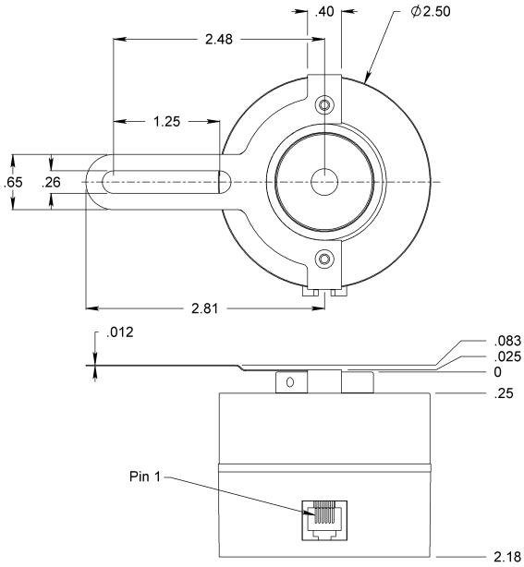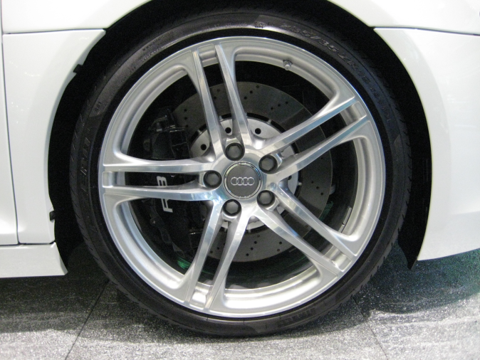

Check out these rims!  
(Example of an annotation) (example of an annotation

Figure 1: This is an example of a dimensioned mechanical drawing (left) and an annotated photo (right). Note this caption was created using References/Insert Caption, which allow MS Word to automatically number and cross reference your figures.

## Electrical Subsystem

All necessary circuitry, signal conditioning components, power supplies and connections should be detailed. Circuit diagrams should include component values (e.g. resistance) as shown in Figure 2. Photos should be annotated, captioned, and referenced within the text. Consider placing complex circuit diagrams in the appendix. Hand-drawn circuit diagrams are only appropriate for the appendix. Include any calibration equations for your sensors or actuators in this section.

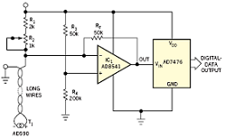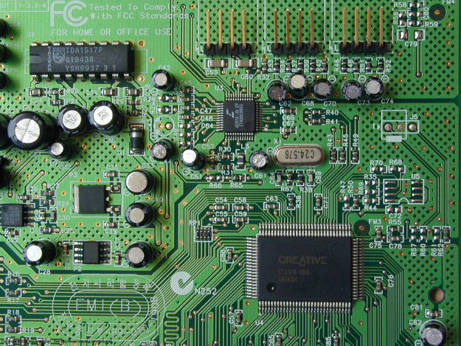

Flux Capacitor   
(example of an annotation)

Figure 2 This is an example of an electrical circuit diagram (left), note the component values are included; and an annotated picture of a fabricated circuit (right).

## Software Subsystem

Within the text, your algorithm or controller design should be in the format of pseudo-code (see Figure 3). It is not necessary to include computer programs in their entirety, though interesting excerpts may be included in the text. Appropriately comment any included code. The documentation needs to clearly indicate what code was written by the group members versus code provided by another source (e.g. faculty, TSD, commercial or open-source software, etc.). For larger, hierarchical programs, represent the functional organization with a flow chart or a block diagram. For programs utilizing GUIs, screen captures of the user interface are useful.

MyProject = NotWorking;

while (MyProject != Working)

WorkHarder;  
WorkSmarter;

end

Figure 3 Pseudo-code is one of the most compact ways to present computer programs. Note that a “pseudo-code style” has been defined in the Style Toolbar of the template.

## Feedback Control

Present your control law as an equation or pseudo-code. See the equation formatting guide in the appendix.

          

Justify how you selected its type (e.g. open loop, bang-bang, proportional, state variable feedback, etc.). Provide values for the gains or coefficients. Discuss their calculation and any iterative design procedure. Provide plots, from either simulations or experiments, illustrating its effectiveness. You can easily create feedback diagrams in PowerPoint using the flowchart shapes. Simply copy and paste your objects into your report as shown in Figure 4. You can copy and paste Matlab figures as shown in Figure 5.

Controller

Plant

Sensor

+

-

Input

Figure 4 Feedback control diagram created in PowerPoint. Note that you can edit the objects in Word. If you decide to use this diagram, edit it to reflect the actual sensor(s) and plant used in your design.

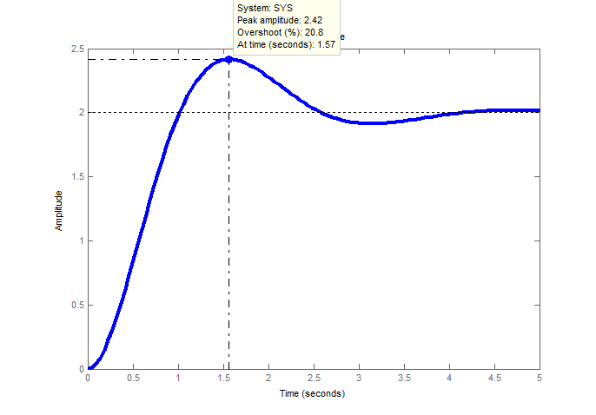

Figure This is the response of the feedback control law. Note that it is scaled appropriately to see the interesting features, and annotated. When importaing Matlab figures, you may need to increase the font size and line width using Matlab to improve legibility.

# Results and Analysis

## Demonstration Plan

This section documents a **procedure** for verifying the performance of your design including a list of required equipment, a list of all initial settings, controlled conditions and the commanded inputs to your system. If you used a test “course” or other apparatus, include a picture. Someone should be able to replicate your experiments based on the instructions you provide in this section.

## Performance Measures

Evaluate your design against the performance measure rubrics, (i.e. your metrics) you developed in EW401. Discuss the extent to which you achieved each objective, striving to include **quantitative analysis** of your system’s performance. Examples include error, speed, settling time, time to set up, usability, etc. Where applicable use appropriate statistical procedures to analyze the data (this should include repeated trials). Use tables or graphs as appropriate to display more detailed results.

Verify that your system satisfies the constraints outlined in the System Design section.

# Project Management

## Work Breakdown Structure

For capstone work involving more than one student, describe the distribution of the workload over the semester. Discuss any specialization or leadership roles in different disciplines, skills, or subsystems. Note that all group members contribute to the writing of the final report and presentation – it should not be one person’s job alone.

## Life Long Learning

As appropriate, briefly discuss any new knowledge that the team members acquired or developed over the course of the capstone project. This may include learning new hardware, software, or techniques.

## Cost analysis and Parts List

Include it in tabular form (see the Appendix for tips on inserting tables). Provide subtotals for parts alone, but also include labor. You may simply update your EW401 material.

## Timeline

Ideally you would present your original proposed Gantt chart or time line from EW401, followed by the revised version reflecting what actually occurred. Be sure the font is legible. At the least, provide a time line of major milestones.

# Discussion and Conclusion

Critique your final results. Discuss contributing factors to the strengths and limitations of your design.

Make recommendations for future midshipmen working on a similar project.

##### Acknowledgment

Thank everyone that helped you. Acknowledge any sponsors.

##### References

Instructions on how to insert references in MS Word appear in the Appendix. The following examples show how most common materials should be referenced using the IEEE standard. Note: parenthetical descriptions do not need to be included in your reference entries.

1. G. O. Young, “Synthetic structure of industrial plastics (Book style with paper title and editor),” in *Plastics*, 2nd ed. vol. 3, J. Peters, Ed. New York: McGraw-Hill, 1964, pp. 15–64.
2. W.-K. Chen, *Linear Networks and Systems* (Book style)*.* Belmont, CA: Wadsworth, 1993, pp. 123–135.
3. H. Poor, *An Introduction to Signal Detection and Estimation* (Book style with chapter ref) New York: Springer-Verlag, 1985, ch. 4.
4. B. Smith, “An approach to graphs of linear forms (Unpublished work style),” unpublished.
5. C. J. Kaufman, Rocky Mountain Research Lab., Boulder, CO, private communication, May 1995.
6. J. U. Duncombe, “Infrared navigation—Part I: An assessment of feasibility (Periodical style),” *IEEE Trans. Electron Devices*, vol. ED-11, pp. 34–39, Jan. 1959.
7. S. P. Bingulac, “On the compatibility of adaptive controllers (Published Conference Proceedings style),” in *Proc. 4th Annu. Allerton Conf. Circuits and Systems Theory*, New York, 1994, pp. 8–16.
8. G. W. Juette and L. E. Zeffanella, “Radio noise currents n short sections on bundle conductors (Presented Conference Paper style),” presented at the IEEE Summer power Meeting, Dallas, TX, Jun. 22–27, 1990, Paper 90 SM 690-0 PWRS.
9. J. Williams, “Narrow-band analyzer (Thesis or Dissertation style),” Ph.D. dissertation, Dept. Elect. Eng., Harvard Univ., Cambridge, MA, 1993.
10. N. Kawasaki, “Parametric study of thermal and chemical nonequilibrium nozzle flow,” M.S. thesis, Dept. Electron. Eng., Osaka Univ., Osaka, Japan, 1993.
11. J. P. Wilkinson, “Nonlinear resonant circuit devices (Patent style),” U.S. Patent 3 624 12, July 16, 1990.
12. *IEEE Criteria for Class IE Electric Systems* (Standards style)*,* IEEE Standard 308, 1969.
13. R. E. Haskell and C. T. Case, “Transient signal propagation in lossless isotropic plasmas (Report style),” USAF Cambridge Res. Lab., Cambridge, MA Rep. ARCRL-66-234 (II), 1994, vol. 2.
14. (Handbook style) *Transmission Systems for Communications,* 3rd ed., Western Electric Co., Winston-Salem, NC, 1985, pp. 44–60.
15. (Basic Book/Monograph Online Sources) J. K. Author. (year, month, day). *Title* (edition) [Type of medium]. Volume (issue). Available: <http://www.(URL>)
16. J. Jones. (1991, May 10). Networks (2nd ed.) [Online]. Available: <http://www.atm.com>
17. (Journal Online Sources style) K. Author. (year, month). Title. *Journal* [Type of medium]. Volume(issue), paging if given. Available: <http://www.(URL>)
18. R. J. Vidmar. (1992, August). On the use of atmospheric plasmas as electromagnetic reflectors. *IEEE Trans. Plasma Sci.* [Online]. *21(3).* pp. 876–880. Available: <http://www.halcyon.com/pub/journals/21ps03-vidmar>

# Appendix: Formatting and Style Guidelines

Appendices are optional and should appear at the end. You may have several appendices if necessary, to include computer programs, large data sets, or detailed drawings. Be sure to note the existence of any appendices or enclosures within the relevant portion of the report text.

This appendix provides stylistic guidelines and MSWord tips on creating linked and cross referenced documents.

## Abbreviations and Acronyms

Define abbreviations and acronyms the first time they are used in the text, even after they have been defined in the abstract. Abbreviations such as IEEE, SI, MKS, CGS, sc, dc, and rms do not have to be defined. Do not use abbreviations in the title or heads unless they are unavoidable.

## Units

The use of SI units is encouraged. English units may be used as secondary units (in parentheses). An exception would be the use of English units as identifiers in trade, such as “3.5-inch disk drive”. Use a zero before decimal points: “0.25”, not “.25”. Use “cm3”, not “cc”.

## Equations

Number equations consecutively. Equation numbers, within parentheses, are to position flush right, as in (2). Punctuate equations with commas or periods when they are part of a sentence, as in

               

Note that the equation is centered. Be sure that the symbols in your equation have been defined before or immediately following the equation. Use “(2)”, not “Eq. (2)” or “equation (2)”, except at the beginning of a sentence: “Equation (2) is . . .”

## Figures and Tables

Place figures and tables at the top and bottom of pages. Avoid placing them in the middle of pages. Figure captions should be below the figures as shown in Figure 6; table captions should appear above the tables as shown Table 1. To insert captions select from the MS Word toolbar *References/Insert Caption.* Reference the figure in the text by choosing the Insert tab and selecting *Cross-reference* from the Links sub-tab. Choose the reference type that you want and be sure to select the appropriate entry in the *Insert reference to* pull-down list. This will only work if you have used *Insert Caption* with the figure or table. This can be achieved by right-clicking on the item or from the References Menu.

Table Captioned Table

| **Table Head** | **Table Column Head** | | |
| --- | --- | --- | --- |
| ***Table column subhead*** | ***Subhead*** | ***Subhead*** |
| copy | More table copya |  |  |

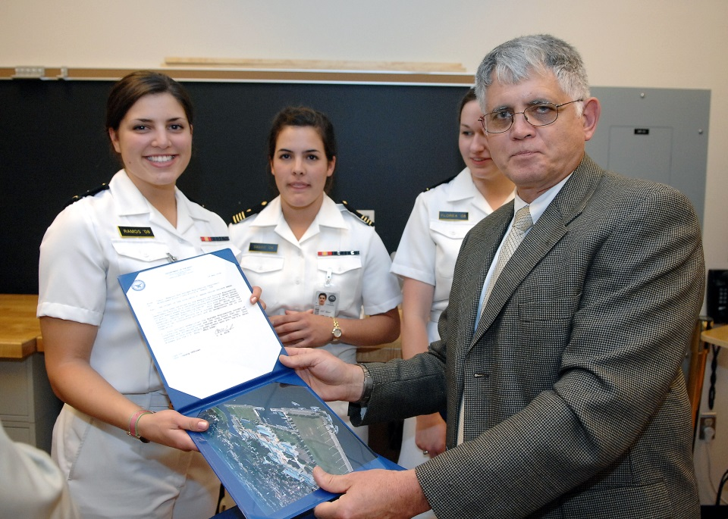

Figure Presentation of the 2007 Marsh Award, which is given each year to the best 1/C Robotics and Control Engineering project in memory of ENS David R. Marsh, USNA Class of 1987, in honor of his enthusiasm for his 1/C project, a voice activated robot.

Axis Labels: Use 8 point Times New Roman for axis label or titles. Use words rather than symbols or abbreviations to avoid confusing the reader. As an example, write the quantity “Magnetization”, or “Magnetization, M”, not just “M”. If including units in the label, present them within parentheses. Do not label axes only with units. In the example, write “Magnetization (A/m)” or “Magnetization {A[m(1)]}”, not just “A/m”.

##### References

Note that, while Word includes many bibliography-building tools, one of the easiest methods to build a lengthy reference list is to move to the end of your document and start a new list of references formatted as follows:

1) Click on the HOME tab at the top of the Word window

2) In the *Paragraph* sub-window, click on the down arrow next to the numbered list layout.

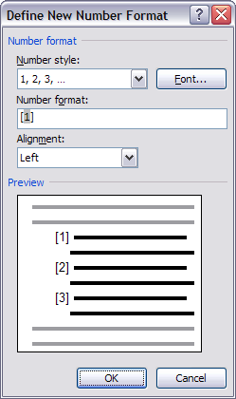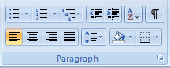

3) Click on the format that shows [#], OR, if that format is not available, select “Define New Number Format” from the bottom of the pop-up window.

4) If you had to define a new number format, select the “Number style” as “1, 2, 3, …” and change the “Number format” to [1] by typing the [ and the ] around the 1, and removing any other punctuation, as shown at right. Select OK when done.

5) Type entries onto the list. It will automatically update.

6) To cross-reference the list, use the method described above in the section on Figures and Tables.

The reference/bibliography standard used in our discipline is published by IEEE, a professional engineering society dedicated to control systems, robotics, electronics, etc. The following examples are provided in the reference section. Note: parenthetical descriptions do not need to be included in your reference entries.

1. Portions of this document were adapted from the IEEE Conference template found at <http://www.ieee.org/conferences_events/conferences/publishing/templates.html> and the ES200 Lab Report Format document.